This Week in the Raven’s Nest

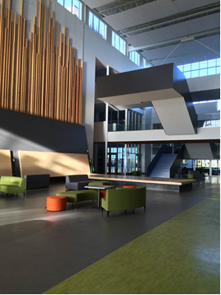

**Monday** April 24

* Beginning of Term 4!!
* Boy’s Rugby Practice 3:45- 5
* Dance Academy to Mary Winspear Center (Sidney) for DanceWorks Festival
* Valedictorian Nomination Week begins – hand in application

**Tuesday** April 25

* Homeroom (whole school)
* Grade 11 Assembly

**Wednesday** April 26

* Island Sexual Health Clinic
* Lt. Governor General Visit and Assembly 10:30 – 11:30
* Boy’s Rugby Practice 3:45- 5
* Dance Academy to (UVIC) for Greater Victoria Performing Arts Festival

**Thursday** April 27

* The Doctor is In” 10-1pm
* Starvation for Education Sleep Over
* Dance Academy to (UVIC) for Greater Victoria Performing Arts Festival

**Friday** April 28

* Cupe Day Of Mourning and Flag Ceremomy
* Friday 1

**RBSS PAC MEETINGS**

**May 3, June 7**

Royal Bay Secondary

School

3500 Ryder Hesjedal Road Victoria, BC. V9C OJ6 [royalbay@sd62.bc.ca](mailto:royalbay@sd62.bc.ca)  T: 250-474-2377

April 24 – April 28, 2017

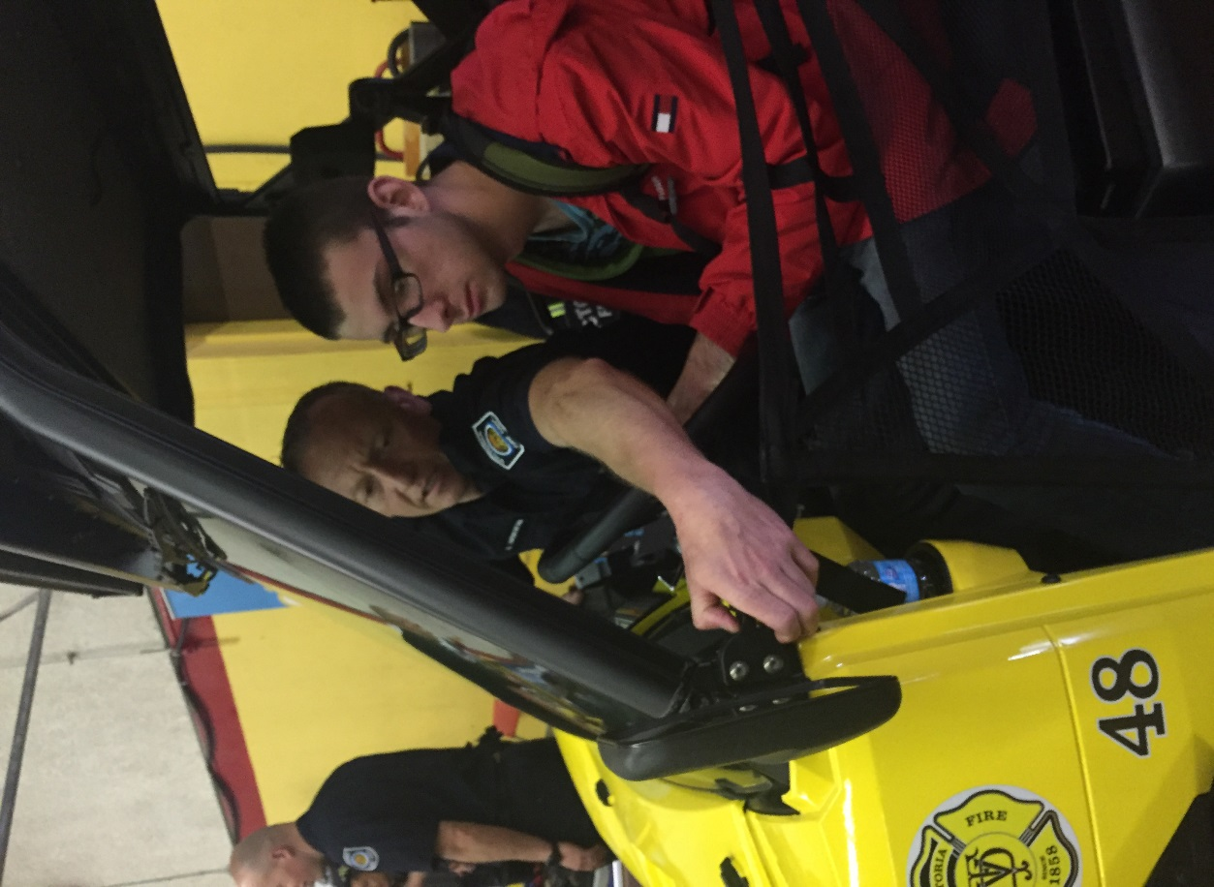

Grade 9 Career Day

Thursday, April 20, saw all the grade 9 Students take part in a large career fair in downtown Victoria, Students met with dozens of schools, business and organizations

Pictured here is Mike L. who is getting some hands on information.

**Volunteer Opportunities**

**Upcoming Events at RBSS**

* April 24th – Dance Academy to Mary Winspear Center (Sidney) for DanceWorks Festival
* April 26th and 27th - Dance Academy to Farquhar Auditorium (UVIC) for Greater Victoria Performing Arts Festival
* Lieutenant Governor General Visit to RBSS April 26
* April 27-28 Starvation for Education – Fasting for CanWes – School in Nepal
* May 2nd Report Cards handed out in Homeroom
* **Urinetown – May 4th, 5th, 11th, 12th**
* May 13 Dry/Safe Grad Carnival
* Soccer Academy Vancouver Tour – Friday, May 19 – Sunday, May 21

Upcoming PAC Elections

Positions available are:

* President
* Treasurer
* Secretary
* Communications Officer

**Voting will take place at the PAC meeting on May 3rd.**

Questions can be directed to [royalbaypac@gmail.com](mailto:royalbaypac@gmail.com)

**Millstream Elementary Spring Fair**

Date:  **Friday May 5th**

Time:  **5 – 8pm**

On-line sign-up

**Please see the Career Centre for applications and more information.**

**Destination UVic**

**Saturday, May 13, 2017**

Join us for Destination UVic: a fun-filled event for student applicants and their families to get a taste of student life on campus at the University of Victoria. We want you to see, hear and feel what it's like to be a UVic student, and there's no better time to find out! (Location : Uvic Student Union Building (9:30am – 3pm)

At Destination UVic, you'll be able to speak with current UVic students, faculty-specific academic advisors, staff members, and future students who have the same questions as you.

* What's it like living in residence?
* What activities can I participate in?
* If I'm accepted, which courses should I choose, and how do I register?
* How much should I budget for my first year?

It's time to take your first step toward becoming a university student, and we'll be right beside you from the moment you arrive until the day you graduate.

Visit us on May 13, and find out if UVic is the right fit for YOU!

**Registration**

**Attention Parents of Work Experience Students**

Many of the students who are enrolled in the Work Experience 12 courses have not submitted a majority of the assignments for this course.  If your child is enrolled in Work Experience 12A or B, please check their report card to see which assignments need to be completed.  If you or your child have questions, please contact Ms. Huculak at [dhuculak@sd62.bc.ca](mailto:dhuculak@sd62.bc.ca) or see me or Mrs. Glanfield in the Careers Office in the Counselling Suite.

Discover UVic is open to all students who have applied for undergraduate studies at UVic starting in September 2017.

Preregistration closes at the end of the day on **Friday, May 12, 2017**.

**Royal Bay Secondary’s Black Wing Theatre Company Presents:**

**Urinetown**

Royal Bay Secondary’s Black Wing Theatre Company proudly presents the Tony Award winning Broadway Hit Urinetown!

In a not too distant dystopic future, a terrible water shortage has led to a government-enforced ban on private toilets. The citizens must use public amenities regulated by a single malevolent company that profits by charging admission for one of humanity’s most basic needs. Among the people, a hero named Bobby Strong decides he’s had enough and organizes a revolution to lead all citizens to peeing freedom. However, Bobby’s revolt becomes complicated when he falls in love with the company director’s daughter, Hope Cladwell. Will Bobby succeed in leading the revolution? Will Hope and Bobby’s love be realized? You might be surprised…

**Urinetown**

The Teechamitsa Theatre at Royal Bay Secondary

3500 Ryder Hesjedal Way

**May 4, 5 and May 11, 12 at 7:00pm**

**May 6 at 2:00 pm**

**Tickets available at the Royal Bay Secondary School office** or at the door

$12.50 for adults

$10.50 for students/seniors

$5.00 for all SD62 students

RBSS Graduation Ceremony and Prom Dates 2017

**The Ravenous Café**

**Monday**

**Breakfast:** Eggs Bennie

**Sandwich/Wrap**:

**Cold Appie**: Tuna Poke

**Hot Main**: Meat ball sub with kale Caesar

**Vegetarian**: Quesadilla with kale Caesar

**Tuesday**

**Breakfast:** Wrap

**Sandwich/Wrap:**

**Cold Appie**: Shrimp cocktail

**Hot Main:** Burrito with side salad

**Vegetarian:** Burrito with side salad

**Wednesday**

**Breakfast:** Breakfast Bagel

**Sandwich/Wrap:**

**Cold Appie:** Assorted Canapes

**Hot Main:** Jerked chicken with grain salad

**Vegetarian:** Jerked tofu with

**Thursday**

**Breakfast:** Bowl

**Sandwich/Wrap:**

**Cold Appie:** Sushi bowl

**Hot Main:** Wonton soup

**Vegetarian:** Vegetarian Wonton soup

Pizza is available in the Learning Commons every Friday $2/slice $5/slice

**Grad Information**

May 29th, 2017 – 9am - 12pm – Grad Rehearsal at the University of Victoria Farquhar Auditorium

June 4th, 2017 – 11 - 3pm – Graduation Ceremony at the University of Victoria Farquhar Auditorium. Tickets will be available through Uvic in April/May

**Prom**

June 9th, 2017 – Empress Hotel 6-11pm

**Dry Grad Carnival**

May 13th, 2017 – Royal Bay Secondary School

Grade 12’s!

Several new scholarships have been added to the **Post-Secondary Preparation 12 DL** Weebly.  You can access them via the following links.

<http://scholarship12dl.weebly.com/april.html>

<http://scholarship12dl.weebly.com/may.html>

<http://scholarship12dl.weebly.com/june.html>

As well, applications are now available for the **District Dogwood/Authority Awards**.  They are valued at **$1250** each.  Last year, over 30 Royal Bay graduates received one of these scholarships.  However, you *must* fill out and submit an application.

**Applications are now available in the Counselling Suite.**  They are due in to **Mrs. Glanfield** by **2:00 pm** on **Tuesday, April 18th.** Click on the following link for further information.

<http://www2.gov.bc.ca/gov/content/education-training/k-12/support/provincial-scholarships/district-authority-scholarships>

Also, a $5000 scholarship from The Union Club has just been uploaded to the Weebly.  It is due on April 30th.

Again, if you have any questions or need any assistance, drop by Room 2125 or send me an e-mail at [jfroess@sd62.bc.ca](mailto:jfroess@sd62.bc.ca).

**Get started *today.***Good luck.

**RBSS CONTACTS**

Windy Beadall – Principal

[wbeadall@sd62.bc.ca](mailto:wbeadall@sd62.bc.ca)

Mike Bobbitt – Vice Principal [mbobbitt@sd62.bc.ca](mailto:mbobbitt@sd62.bc.ca) Students A to J

Mike Huck – Vice Principal [mhuck@sd62.bc.ca](mailto:mhuck@sd62.bc.ca) Students K to Z

Tebeth Barbour – Counselor

[tbarbour@sd62.bc.ca](mailto:tbarbour@sd62.bc.ca)

Students A to J

Wendy Cooper – Counselor [wcooper@sd62.bc.ca](mailto:wcooper@sd62.bc.ca) Students K to Z

**RBSS Cashless School Option**

Royal Bay will be evaluating a new system to provide parents, students and staff with a way to manage cafeteria, clothing and vending purchases through a cashless system starting September 2017.

This system will be coordinated with the new SD62 accounting software (KEV) and allow parents to load money onto their students’ ID card (current student cards) and manage purchases through the cafeteria, vending machines and other in school purchases (school clothing, etc.,). In order to have access to this system, please ensure you complete the consent forms for this program by clicking on this link: <https://sd62.schoolcashonline.com/>

**RBSS Leadership Events**

Starvation for Education:

Leadership is putting on an exciting fundraiser for the CanWES foundation called Starvation for Education on April 27th. At this event, participants will not eat for 24 hours to raise awareness and funds for children in Nepal. It starts on April 27th at 8am, and continues until 8am on the 28th, including a sleepover at the school, movies, games, dodgeball and free breakfast. The participation cost is a minimum of $40 per person, to be collected as donations from family, friends, and neighbours. Sign up sheets and pledge forms will be available in the office. If you're interested, the next meeting is on Wednesday, April 19th at lunch in the learning commons. All pledge forms, donations, and permission forms are due back on April 26th. Hope to see you there!

**From the Learning Commons:**

If you have books, puzzles and/or games that you would like to find a new home for, the Royal Bay Learning Commons will graciously accept these items.  Please drop items off in the LC or at the main office.  Leave your name and we will acknowledge your donation with a donation plate inside the front cover of the books.

The Royal Bay Library/Learning Commons has received a grant from the Times Colonist Raise a Reader fund for $2000 to fund a project that will allow us to build our collection to support the acquisition of knowledge regarding local plants, animals and coastal environments, as well as promoting environmental stewardship and Aboriginal worldviews and perspectives. We send out a HUGE thank you to the Times Colonist and all of the volunteers that support the Raise a Reader book sale.

This content will be added to the library collection in the coming weeks, stop by to check out the new additions.

***************************************************************



**Eat Your Greens On Wednesdays!**

Starting next Wednesday, April 26th, there will be a self-serve salad bar set up in the Aviary!

Come help yourself to a  nutritious and tasty lunch! $5/plate.

**2016/2017 RBSS GRAD Dates/Deadlines:**

Friday, March 17 **Grad Gown order** must be completed and submitted to office.

Friday, April 7 Completed Grad Package submitted to the main office this includes: Ceremony comment form and **$50.00 graduation fee**

Cheques payable to: School District 62

Friday, April 21 **Grad ceremony** ticket reservations begin through **UVic box office**. Tickets are $5 each and payment is made to UVic at the time of purchase. Instructions will be emailed at the beginning of April (Grad Package must be submitted in order to access tickets)

Thursday, May 4 **“O Canada”** and **Original Grad Song** audition at lunch in the Choir room. A copy of the lyrics MUST be presented at the time of audition.

April 24- April 28 **Valedictorian Nomination Week** (20 signatures required) Tuesday, May 9 **Vote for valedictorian** during a special assembly after TAG

Saturday, May 13 **RBSS Dry Grad Carnival at RBSS 6 pm – 2 am**

Friday, May 19 **Grad Status Confirmation:** Grade 12 students must be in

the position to graduate in order to participate in the Grad ceremony. All fees will be refunded if a student is not in a

position to graduate.

Monday, May 29 **Graduation ceremony rehearsal** at UVic Auditorium

University Centre. Buses will depart RBSS at 9am and return when complete (approximately 1pm)

Sunday, June 4 **Graduation ceremony** at UVic Auditorium University

Centre, 11:00 am

Saturday, June 9 **Prom at the Empress 6 pm – 11 pm**